PARIS Fashion Week
STELLA McCARTNEY Summer 2023 Show

Hair Design by Lead Stylist Eugene Souleiman for Moroccanoil

INSPIRATION: “This season is all about empowering women by enhancing their natural beauty and giving them confidence by emphasizing their personality and unique hair texture. We created effortless, healthy-looking hairstyles by customizing Moroccanoil hair products, allowing hair to look at its best. These products allow you to be creative and playful without leaving any residue or buildup, enhancing the natural patterns of the hair to make it look and feel luxurious. Fearless hair makes you feel that you can conquer the world.
We know the importance of empowering the younger generation, so we chose to show a diversity of models, hair lengths, and textures, so that everyone can relate and identify themselves with what they see on the runway.” —Eugene Souleiman, lead stylist for Moroccanoil
Photo Credit: Mohamed Khalil

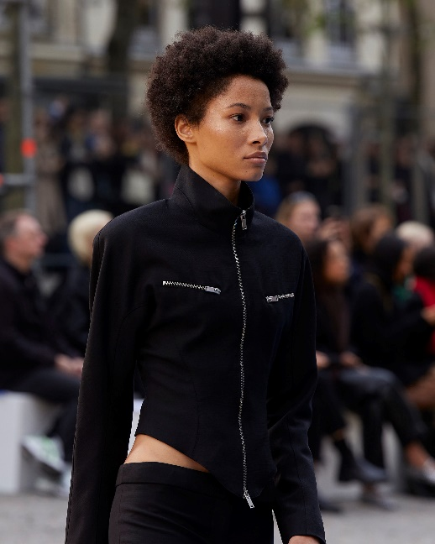
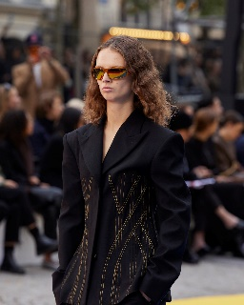
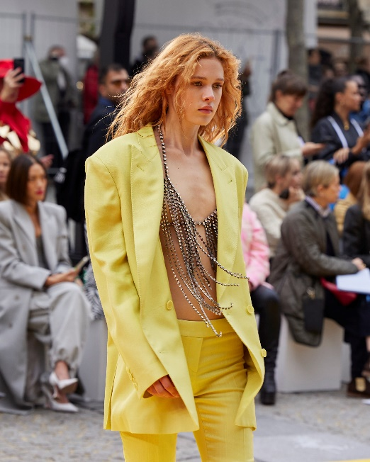

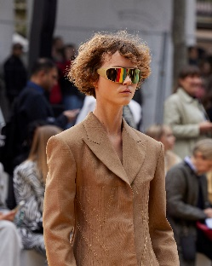

GET THE LOOK FOR CURLY HAIR:

- Apply a dime-size amount of Moroccanoil Treatment from mid-lengths to ends to provide the perfect foundation for styling. For short hair, apply globally.
- Apply 1–2 pumps of Moroccanoil Curl Control Mousse in the palm of your hands, emulsify, and apply from roots to ends. This will create defined and well-hydrated coils.
- Let the hair dry naturally or diffuse with the Moroccanoil Power Performance Ionic Hair Dryer.
- Finish the look by applying Moroccanoil Glimmer Shine for a glossy, luminous effect.

Moroccanoil Treatment | Moroccanoil Curl Control Mousse | Moroccanoil Power Performance Ionic Hair Dryer |
Moroccanoil Glimmer Shine |

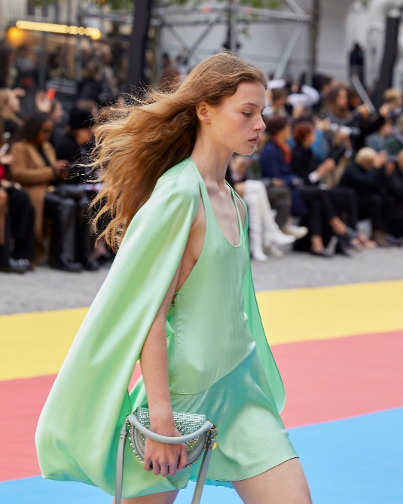
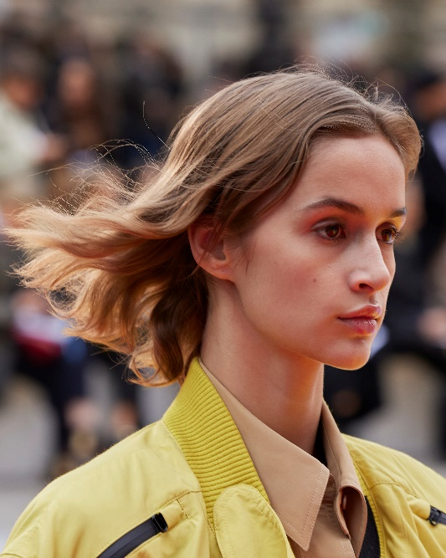
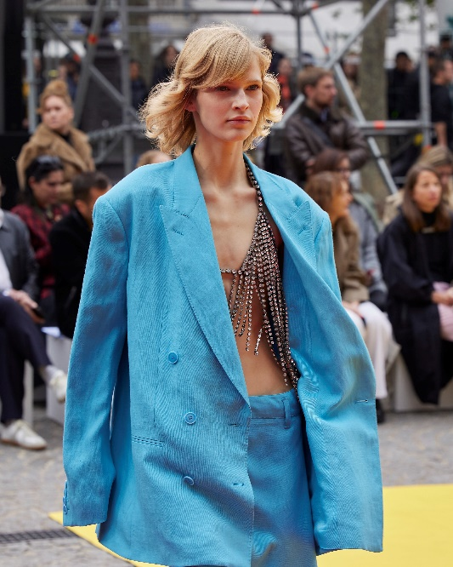

GET THE LOOK FOR NATURAL WAVY HAIR:

- Apply a dime-size amount of Moroccanoil Treatment—or Moroccanoil Treatment Light for fine or light-colored hair—from mid-length to ends to provide the perfect foundation for styling.
- Apply 1–2 pumps of Moroccanoil Curl Defining Cream from mid-lengths to ends. This product will activate and enhance the natural wave pattern of the hair, making it feel airy and full of movement.
- Diffuse hair with the Moroccanoil Power Performance Ionic Hair Dryer. Avoid touching the hair while you are diffusing until it is dry, to prevent any frizz.
- Once hair is dry, apply 1 pump of Moroccanoil Mending Infusion to seal the ends and create separation of the hair strands.

Moroccanoil Treatment (Original and Light) | Moroccanoil Curl Defining Cream | Moroccanoil Power Performance Ionic Hair Dryer | Moroccanoil Mending Infusion |

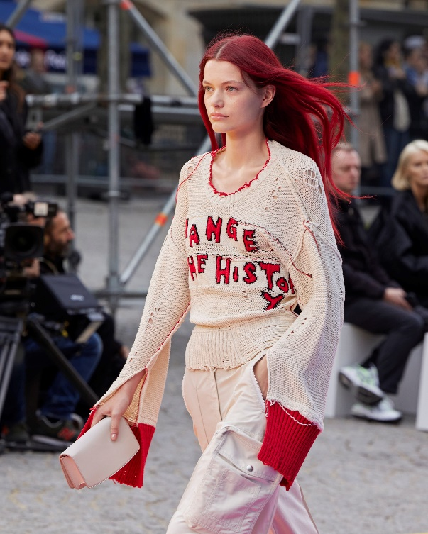
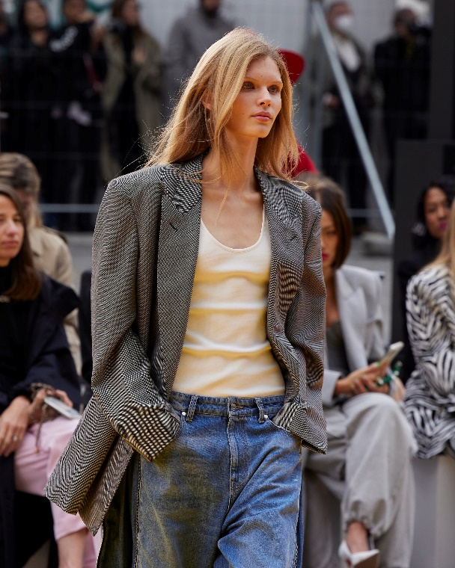

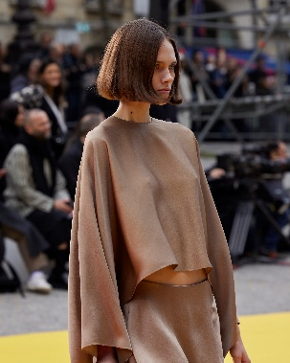

GET THE LOOK FOR STRAIGHT HAIR:
- Apply a dime-size amount of Moroccanoil Treatment—or Moroccanoil Treatment Light for fine or light-colored hair—from mid-lengths to ends to provide the perfect foundation for styling.
- Apply 1 pump of Moroccanoil Hydrating Styling Cream from mid-lengths to ends.
- Blow-dry with the Moroccanoil Power Performance Ionic Hair Dryer and a Moroccanoil Ceramic 45 mm Round Brush, keeping the natural look and volume of the hair.
- Part hair in the middle and pull both sides behind the ears, to maintain an effortless look. Apply Moroccanoil Luminous Hairspray Strong to secure both front sections behind the ears and provide long-lasting hold.
- Spray a hint of Moroccanoil Dry Texture Spray globally to create texture and an effortless vibe.

Moroccanoil Treatment (Original and Light) | Moroccanoil Hydrating Styling Cream | Moroccanoil Power Performance Ionic Hair Dryer |Moroccanoil Ceramic 45 mm Round Brush | Moroccanoil Luminous Hairspray Strong |

For more info: Moroccanoil.com

ABOUT MOROCCANOIL:
Inspired by the Mediterranean, the Moroccanoil brand comes to life through our iconic turquoise packaging and signature fragrance, for an exotic experience that transports the senses. Our first product, the original Moroccanoil Treatment, pioneered oil-infused haircare and created the worldwide buzz on argan oil. At the heart of our brand is the stylist community that inspires us to create effective and easy-to-use products. Today, our goal remains unchanged: to continue pioneering innovation in beauty, while using our platform to make a difference.

Moroccanoil hair and body products are available at fine salons and retailers, spas, and online in over 70 countries worldwide. Visit us at Moroccanoil.com. For daily inspiration, follow @Moroccanoileu on Instagram; subscribe to our beauty tutorials on YouTube, and find us on Facebook!

###

